**Use a token as a password for signing in with PgAdmin OR Any other GUI PostgreSQL Client Tool.**

To connect Database by using a Microsoft Entra token with PgAdmin, Kindly follow these steps:

1. Open Pgadmin and click **Register** from left hand menu and select **Server**
2. In **General** Tab provide a connection name and clear the **Connect now** option.
3. Click the **Connection** tab and provide your Azure Database for PostgreSQL flexible server instance details for **Hostname/address** and **username** and save. **username is your Microsoft Entra ID or email**
4. From the browser menu, select your Azure Database for PostgreSQL flexible server connection and click **Connect Server**
5. Enter your Active Directory token password when prompted.

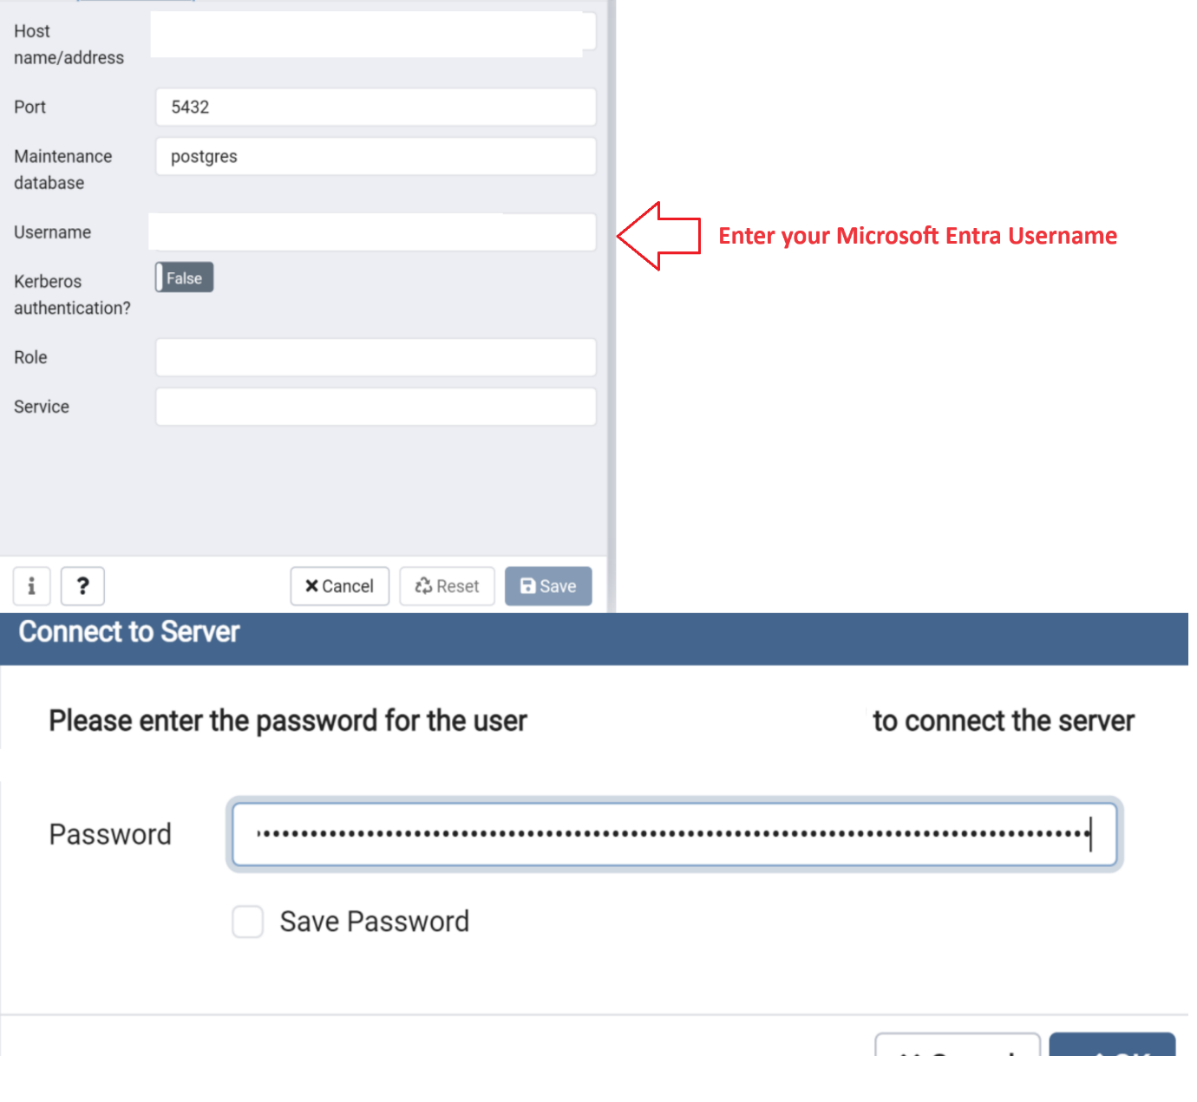

Here are some essential considerations when you're connecting:

* user@tenant.onmicrosoft.com is the userPrincipalName of the Microsoft Entra user.
* Be sure to use the exact way the Azure user is spelled. Microsoft Entra user and group names are case-sensitive.
* If the name contains spaces, use a backslash (\) before each space to escape it. You can use the Azure CLI to get the signed in user and set the value for PGUGSER environment variable:

BashCopy

export PGUSER=$(az ad signed-in-user show --query "[userPrincipalName]" -o tsv | sed 's/ /\\ /g')

* The access token's validity is 5 minutes to 60 minutes. You should get the access token before initiating the sign-in to Azure Database for PostgreSQL.

You're now authenticated to your Azure Database for PostgreSQL server through Microsoft Entra authentication.

**Authenticate with Microsoft Entra ID as a group member**

**Create Microsoft Entra groups in Azure Database for PostgreSQL flexible server**

To enable a Microsoft Entra group to access your database, use the same mechanism you used for users, but specify the group name instead. For example:

SQLCopy

select * from pgaadauth_create_principal('Prod DB Readonly', false, false).

When group members sign in, they use their access tokens but specify the group name as the username.

**Note**

Azure Database for PostgreSQL flexible server supports managed identities and service principals as group members.

**Sign in to the user's Azure subscription**

Authenticate with Microsoft Entra ID by using the Azure CLI. This step isn't required in Azure Cloud Shell. The user needs to be a member of the Microsoft Entra group.

Azure CLICopy

Open Cloud Shell

az login

**Retrieve the Microsoft Entra access token**

Use the Azure CLI to acquire an access token for the Microsoft Entra authenticated user to access Azure Database for PostgreSQL. Here's an example of the public cloud:

Azure CLICopy

Open Cloud Shell

az account get-access-token --resource https://ossrdbms-aad.database.windows.net

You must specify the initial resource value exactly as shown. For other clouds, you can look up the resource value by using the following command:

Azure CLICopy

Open Cloud Shell

az cloud show

For Azure CLI version 2.0.71 and later, you can specify the command in the following convenient version for all clouds:

Azure CLICopy

Open Cloud Shell

az account get-access-token --resource-type oss-rdbms

After authentication is successful, Microsoft Entra ID returns an access token:

JSONCopy

{

"accessToken": "TOKEN",

"expiresOn": "...",

"subscription": "...",

"tenant": "...",

"tokenType": "Bearer"

}

**Use a token as a password for signing in with psql or PgAdmin**

These considerations are essential when you're connecting as a group member:

* The group name is the name of the Microsoft Entra group that you're trying to connect.
* Be sure to use the exact way the Microsoft Entra group name is spelled. Microsoft Entra user and group names are case-sensitive.
* When you're connecting as a group, use only the group name and not the alias of a group member.
* If the name contains spaces, use a backslash (\) before each space to escape it.
* The access token's validity is 5 minutes to 60 minutes. We recommend you get the access token before initiating the sign-in to Azure Database for PostgreSQL.

You're now authenticated to your PostgreSQL server through Microsoft Entra authentication.